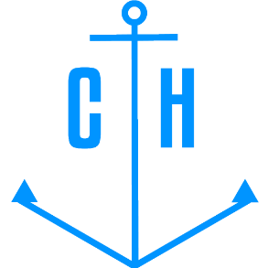 | CV  (Application Form)  FIRST NAME SECOND NAME  Certified for:  RANK | photo

Main info
Name / Surname:
Position applied for: |  | Desired Vessel Type:
Minimum salary $: |  | Birthday / Place of birth:
Phones |  | Citizenship:
E-mail: |  | Country of residence /  City:
Messenger: |  | Home address:
English level: |  | Closest airport:
USA visa valid up: |  | Schengen visa valid up:

Passports / Seamans book
Title of document | No. | Date of issue | Country of issue | Valid up
Seaman's book
International passport
National passport

Diplomas
Title of document | No. | Date of issue | Country of issue | Valid up
Rank
Professional license
Endorsement

Certificates
Title of document | No. | Date of issue | Country of issue | Valid up
Medical First Aid
GMDSS Operator
GMDSS Endorsement
Radar Management (ARPA+Radar)
ECDIS
Ship Carrying Dandr/hazard Cargo
Medical Care
Advanced Fire Fighting
Basic Safety Training
Proficiency in Survival Craft and RB
Ship Security Officer
Ship Safety Officer
Bridge Resources Management
Other Certificate
Add here
Other Certificate
Add here
Other Certificate
Add here
Other Certificate
Add here
Other Certificate
Add here

Medical certificates
Title of document | No. | Date of issue | Country of issue | Valid up
Physical examination report

Flag Documents and Other Countries Seaman's Books
Country | Document type | No. | Date of issue | Valid up
Panama
Norway
Antigua and Barbuda
Panama

Sea service (last 5 years)
Position | Vessel Name / Flag | Vessel type / DWT | ME Type / kW | From - Till | Shipowner / Country

Biometrics
Sex: | Height: | Overall size:
Eyes color: | Weight: | Shoe size:

Additional info
Maritime education: |  | Additional skills:
Speciality: |  | Knowledge of other  languages:
Next of Kin
Next of kin: |  | Kin phone:
Kin name, Surname: |  | Kin address:

Notes

